Вариант 8

$$f\left(\overline{x}\right)=x_{1}^{4}+x_{2}^{4}+\sqrt{2+x_{1}^{2}+x_{2}^{2}}-2x_{1}+3x_{2}, {\overline{x}}_{0}=(0;0)$$

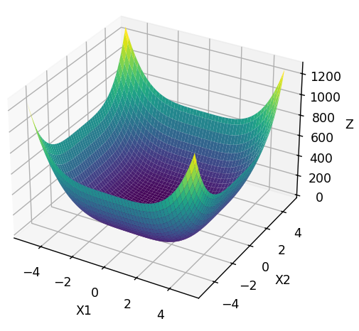

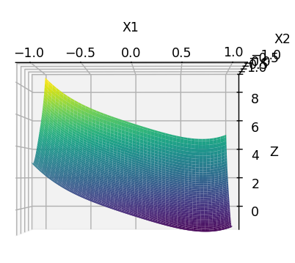

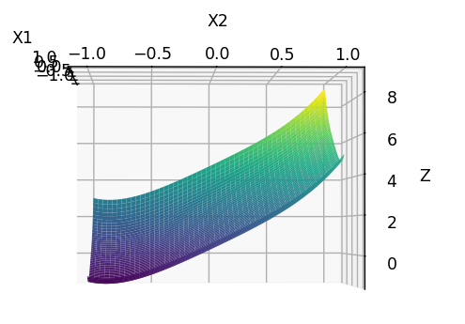

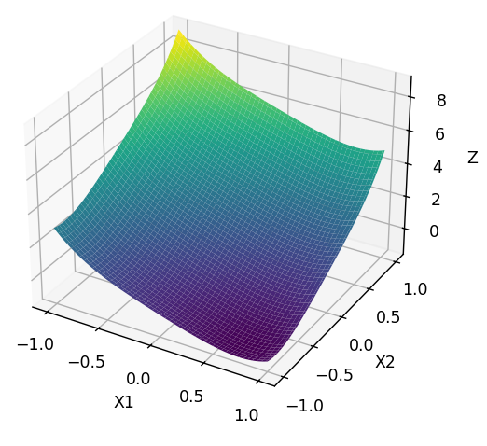

|  |  |  |  |  |  |
| --- | --- | --- | --- | --- | --- |
| Альфа | 0,1 | 0,2 | 0,3 | 0,4 | 0,5 |
| X1 | 0.7358153 | 0.7358162 | 0.7358162 | 0.7358162 | 0.7358163 |
| X2 | -0.8579524 | -0.8579529 | -0.8579530 | -0.8579519 | -0.8579520 |
| Y | -1.4001420 | -1.4001420 | -1.4001420 | -1.4001420 | -1.4001420 |
| Шаги | 15 | 79 | 14 | 70 | 10 |

Для Нелдера-Мида:

|  |  |  |  |
| --- | --- | --- | --- |
| X1 | X2 | Y | Шаги |
| 0.7358455 | -0.8579706 | -1.4001420 | 36 |